



Essay / Assignment Title: Exploring Data Trends through Interactive Visual Analytics using Tableau: A Climate, Energy and Sustainability Dashboard

Programme title: MSc Data Analytic
Module: Visualization and Storytelling using Tableau
Issued by: Dr. Eng. Loubna Ali
Name:

Year: 2026
Submission Date: 08 May 2026

CONTENTS

INTRODUCTION 4
CHAPTER ONE: DATASET AND PREPARATION 5
1.1 Data Sources 5
1.2 Data Preparation Pipeline 5
1.3 The Composite Sustainability Score 6
1.4 Final Dataset Scope 6
CHAPTER TWO: VISUAL ARTEFACTS IN TABLEAU 7
2.1 Average CO2 Emissions per Capita by Region 8
2.2 Top N Countries by CO2 per Capita 9
2.3 Renewable Energy Consumption Map 9
2.4 Economic Development and CO2 Emissions 10
2.5 Regional CO2 Emissions Heatmap 11
2.6 Top 20 Countries by Composite Sustainability Score 11
2.7 Renewable Energy Adoption by Income Group 12
CHAPTER THREE: DASHBOARD DESIGN AND EXCEL COMPONENT 13
3.1 Integrated Tableau Dashboard 13
3.2 Excel Component 13
3.2.1 Pivot Chart with Slicer 14
3.2.2 Combo Chart with Dual-Axis 14
CHAPTER FOUR: JUSTIFICATION OF TABLEAU FEATURES AND REFLECTION 15
4.1 Tableau Features Used 15
4.2 Reflection on Trends 15
4.3 Limitations 16
CONCLUDING REMARKS 17
BIBLIOGRAPHY 18
APPENDIX 19
Appendix A - Final Dataset Schema 19
Appendix B — Tableau Workbook Contents 19
Appendix C — Excel Workbook Contents 20

Statement of compliance with academic ethics and the avoidance of plagiarism

I honestly declare that this assignment is entirely my own work and none of its part has been copied from printed or electronic sources, translated from foreign sources, or reproduced from essays of other researchers or students. Wherever I have been based on ideas or texts of other people I clearly declare it through the good use of references following academic ethics.
(In the case that is proved that part of the essay does not constitute an original work, but a copy of an already published essay or from another source, the student will be expelled permanently from the postgraduate program.)

Name and Surname (Capital letters):

.......................................................................................................................................

Date: ........................./........../.........

INTRODUCTION

The Intergovernmental Panel on Climate Change has concluded that the world is not likely to constrain warming to 1.5 C without immediate, deep emissions reductions (IPCC, 2023). To translate that abstract verb into practical insight would require the tools that would allow high-dimensional data to be legible to non-specialist audiences. The work fits the Public Health and Social Development Patterns domain since the climate transition is itself a development issue: the energy and emissions are the centre of the human-development policy (United Nations, 2015).
The analytical aim is to study how 199 countries diverged over three dimensions carbon intensity, adoption of renewable energy, and a composite sustainability score between 2008 and 2022.

CHAPTER ONE: DATASET AND PREPARATION

1.1 Data Sources
The dataset is primarily based on the World Bank Open Data portal (World Bank, 2026), the default source of international development indicators. We cross-validated emissions numbers with our World in Data (Ritchie and Roser, 2024) since OWID is a compilation of input sources, such as the Global Carbon Budget and the IEA (2024). The World Bank API was used to retrieve seven indicators:
Indicator | World Bank Code | Unit
CO2 emissions per capita | EN.GHG.CO2.PC.CE.AR5 | tonnes CO2e per person
Renewable energy consumption | EG.FEC.RNEW.ZS | % of total final energy
Energy use per capita | EG.USE.PCAP.KG.OE | kg oil equivalent / person
GDP per capita | NY.GDP.PCAP.CD | current US$
Population, total | SP.POP.TOTL | persons
Access to electricity | EG.ELC.ACCS.ZS | % of population
Forest area | AG.LND.FRST.ZS | % of land area

1.2 Data Preparation Pipeline
The preparation was done in Python (pandas) such that all transformations can be reproduced by the source. All the indicators were obtained via World Bank API, transformed to long format, and combined on (Country_Code, Year). World Bank metadata was brought in as Region and Income_Group, with regional aggregates (such as World and OECD members) being excluded to avoid double-counting. Missing values were handled asymmetrically, with missing values in Energy_Use, Forest_Area and Electricity_Access forward-filled within a country to maintain trend continuity, whilst missing CO2 values caused row exclusion in a country to preserve trend continuity. Three derived columns were added CO2_Total_megatons, Emission_Category, and the Sustainability_Score in addition to capital-city coordinates and a Period grouping (20082015 vs 20162025). The output was exported in form of cleaned climate dashboard data.csv and an excel workbook.

1.3 The Composite Sustainability Score
A custom score was created in Python and recreated as a Tableau calculated field:
Sustainability Score = (Renewable Energy % × 0.5) + (CO2_score × 0.3) + (Forest Area % × 0.2)
where CO2_score = 100 − min(CO2_per_capita × 5, 100). The weights give preference to the renewable adoption (50%) as the most actionable policy lever, the intensity of emissions (30 %), and the forest cover (20 %) as a proxy of the carbon-sink. Greco et al. (2019) warn that any composite measure incorporates the judgments of value of its creator; therefore, the weights are reported in an open manner. Section 4.2 goes back to this with a substantive critique.

1.4 Final Dataset Scope
The cleaned data set has 2,847 country-year observations in 199 countries and seven world bank regions. Each year between 2008 and 2021 has almost complete (197-199 countries) coverage of the country for every year, except in 2022 where only 65 records were available due to the typical 1218-month delay by the World Bank to publish its results. Each trend statement is based on the 2008-versus-2021 comparison, with 2022 only used to visually represent the comparison.

CHAPTER TWO: VISUAL ARTEFACTS IN TABLEAU

Figures 1 and 2 show the Tableau data pane, which contains the calculated fields and parameters that power the interactivity of the dashboard.
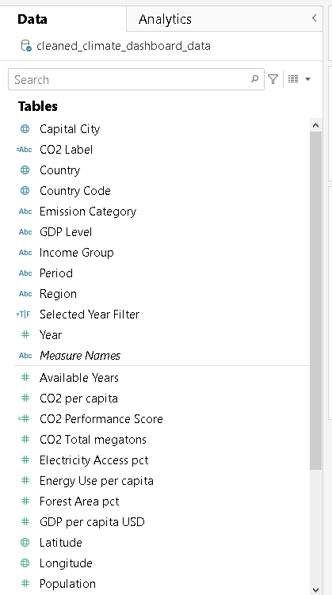
Figure 1. Tableau data pane showing measures, dimensions, and calculated fields including Sustainability Score, Selected Metric and Available Years.
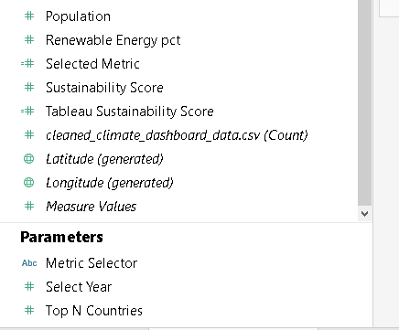
Figure 2. Continued data pane view showing parameters (Metric Selector, Select Year, Top N Countries) used across multiple worksheets.

2.1 Average CO2 Emissions per Capita by Region
The linear trend lines of the regional series indicate that all the high-emission regions including North America, Middle East and Europe, Central Asia all slope downwards. The regional average decreased by 19.5 percent, by 2008-2021, to 6.10 tonnes per capita, a fall of 7.58. South Asia increases by 1.01 to 1.57 tonnes, which represents a 55 percent relative growth on a low base. The endpoints drop sharply in several locations in 2022; this is an artefact of partial coverage of 2022 as opposed to actual collapse of emissions.
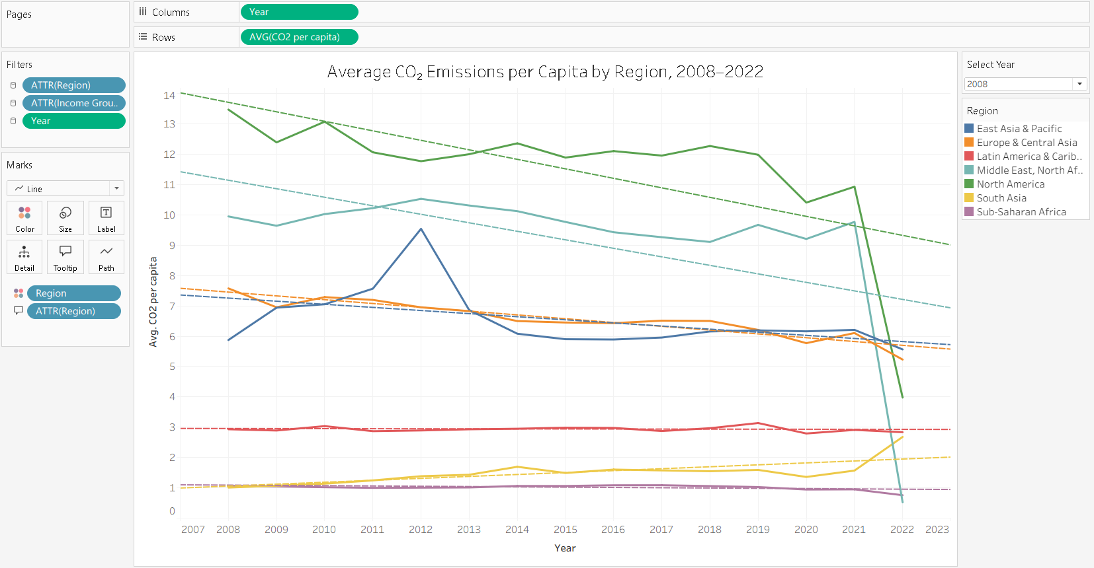
Figure 3. Average CO2 emissions per capita by region, 2008–2022, with linear trend lines.

2.2 Top N Countries by CO2 per Capita
The second worksheet (Figure 4) reframes the same data around individual countries and is parameterised so the user can adjust the cutoff (Top N) and snapshot year. The 2022 ranking is dominated by Palau (73.5), Qatar (43.4), Kuwait (31.5) and Trinidad and Tobago (29.5) — small economies whose per-capita figures inflate disproportionately because the population denominator is small relative to a fossil-fuel-intensive industrial base. Absolute contribution to global emissions should not be confused with per-capita rankings, which is significant to policy attribution.
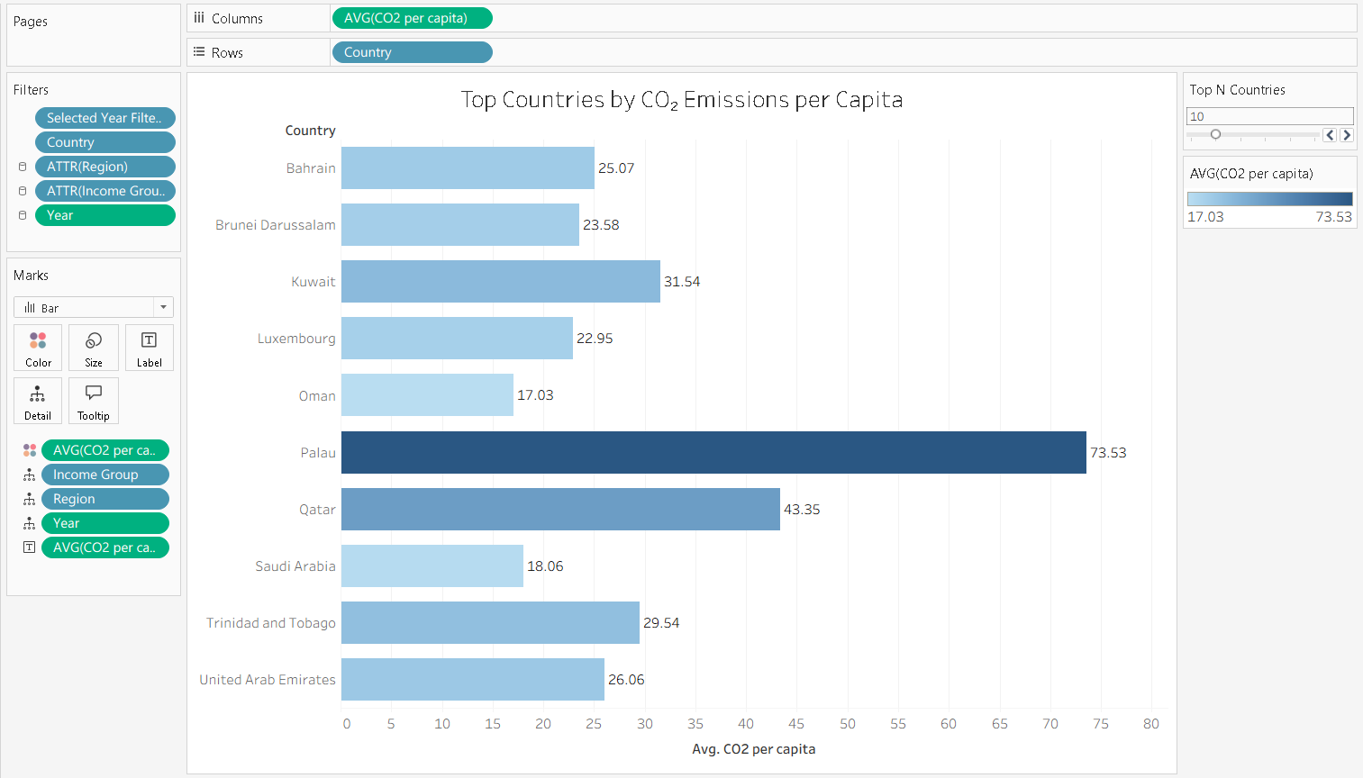
Figure 4. Top N countries by CO2 per capita, controlled by an interactive Top N parameter.

2.3 Renewable Energy Consumption Map
The third worksheet (Figure 5) is a filled choropleth with Tableau geographic role on Country_Code. Countries in Sub-Saharan Africa are strongly green, although the explanation is merely a methodological one: the renewable indicator of the World Bank includes traditional biomass, as well as modern wind, solar and hydro. Third world nations thus record large renewable quotas even with less modern infrastructure, a situation that proves that aggregate numbers may be as misleading as they are informative.
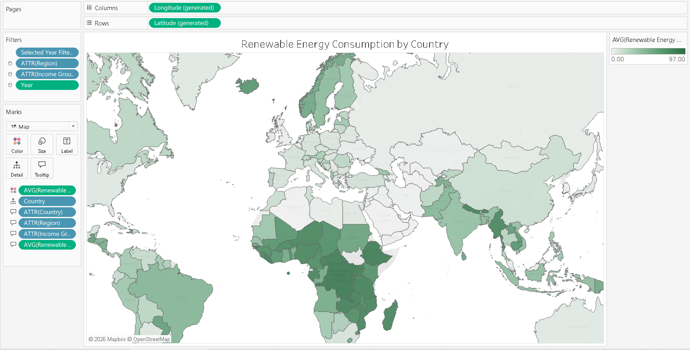
Figure 5. Renewable Energy Consumption by country (regional zoom on Africa). Colour intensity reflects renewables' share in final energy use.

2.4 Economic Development and CO2 Emissions
The fourth worksheet (Figure 6) tests a long-standing hypothesis in environmental economics: that the relationship between income and carbon emissions is non-linear, and wealth is eventually decoupled to carbon intensity (Stern, 2017). A scatter plot of GDP v CO2 with marks proportional to the population and the colour of the mark depending on the region gives a positive but flattening relationship. The Pearson correlation between log(GDP) and CO2 is r = 0.43, representing a real but moderate association consistent with several high-income economies moving off the historical curve. The logarithmic trend line was employed due to the dispersion of the residual values at the high GDP, which made the linear fit inappropriate.
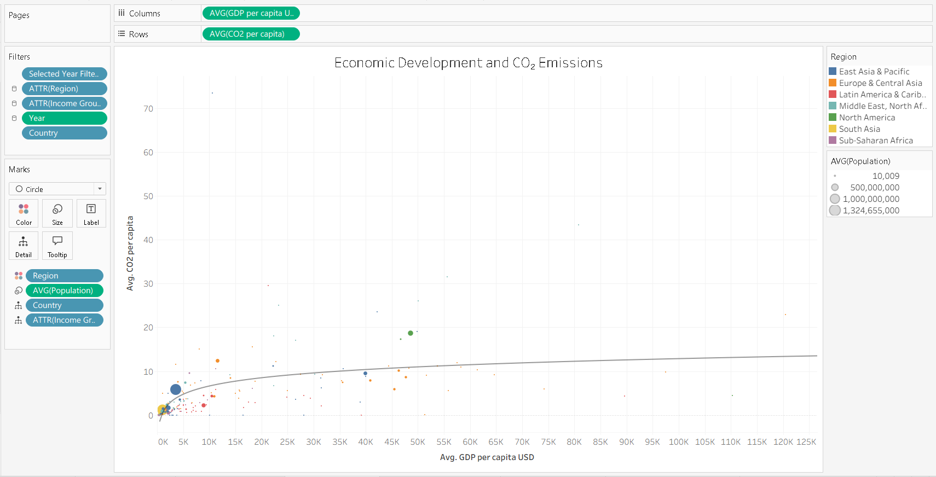
Figure 6. GDP per capita versus CO2 per capita, with population-weighted marks and a logarithmic trend line.

2.5 Regional CO2 Emissions Heatmap
Figure 7 (the fifth worksheet) cross tabulates Region by Year on red-yellow gradient. North America is the core of the deepest red marking all over, whereas Sub-Saharan Africa remains on the lightest band. The format sacrifices accuracy to pattern recognition in real time.
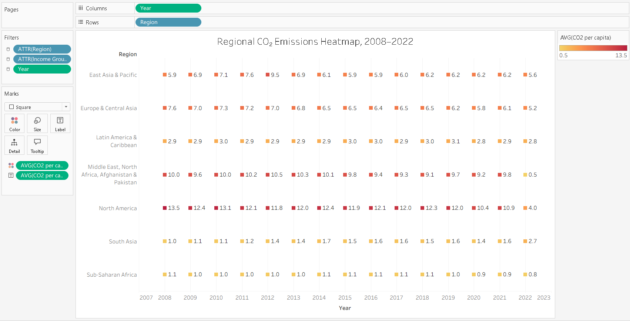
Figure 7. Regional CO2 emissions heatmap, 2008–2022.

2.6 Top 20 Countries by Composite Sustainability Score
The sixth worksheet (Figure 8) lists the 20 leading countries with the composite Sustainability Score. Top in Liberia (92.2), Democratic Republic of the Congo (90.7) and Guinea-Bissau (88.7).
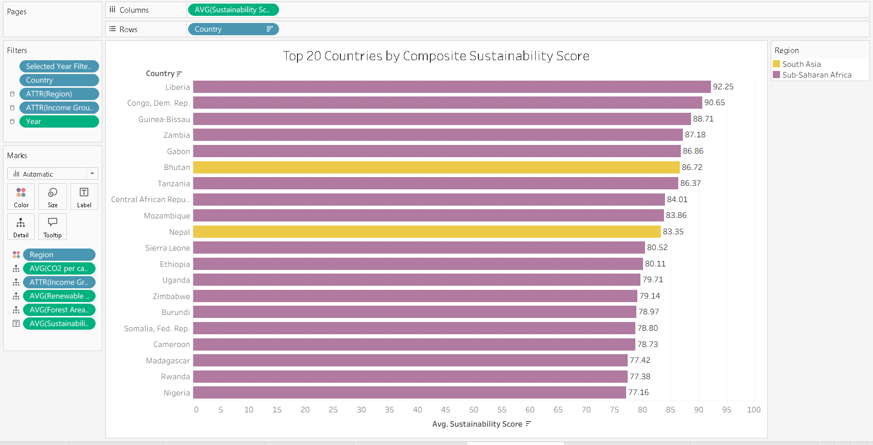
Figure 8. Top 20 countries by composite Sustainability Score (custom calculated field).

2.7 Renewable Energy Adoption by Income Group
The seventh worksheet (Figure 9) plots renewable-share trajectories by income group. The pattern of the headline is divergence: low-income countries remain above 70 percent throughout (driven by biomass), high-income countries rise between 11.4 and 16.0% a relative increase of 40 percent. Denmark, with its good renewable investment framework, has the largest individual jumps, followed by Estonia and Luxembourg.
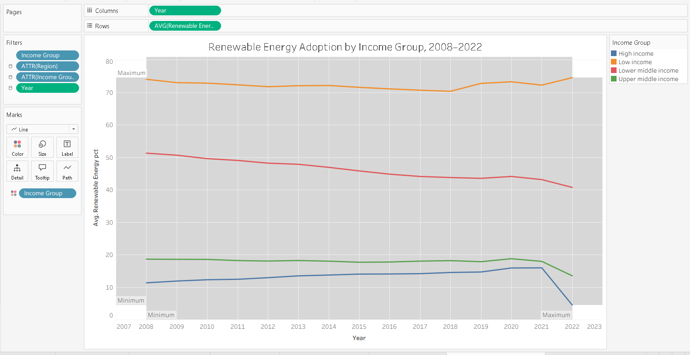
Figure 9. Renewable energy adoption trajectory by income group, 2008–2022.

CHAPTER THREE: DASHBOARD DESIGN AND EXCEL COMPONENT

3.1 Integrated Tableau Dashboard
The dashboard (Figure 10) takes five worksheets on a single canvas. Layout adheres to the conventions of an analytical interface, with the headline time series taking up the upper-left so users can learn about it first, followed by views sit on the right and the geographic map sit in the lower-left where it can breathe. Filter controls appear together on the right margin in order to make a distinction between navigation and content.
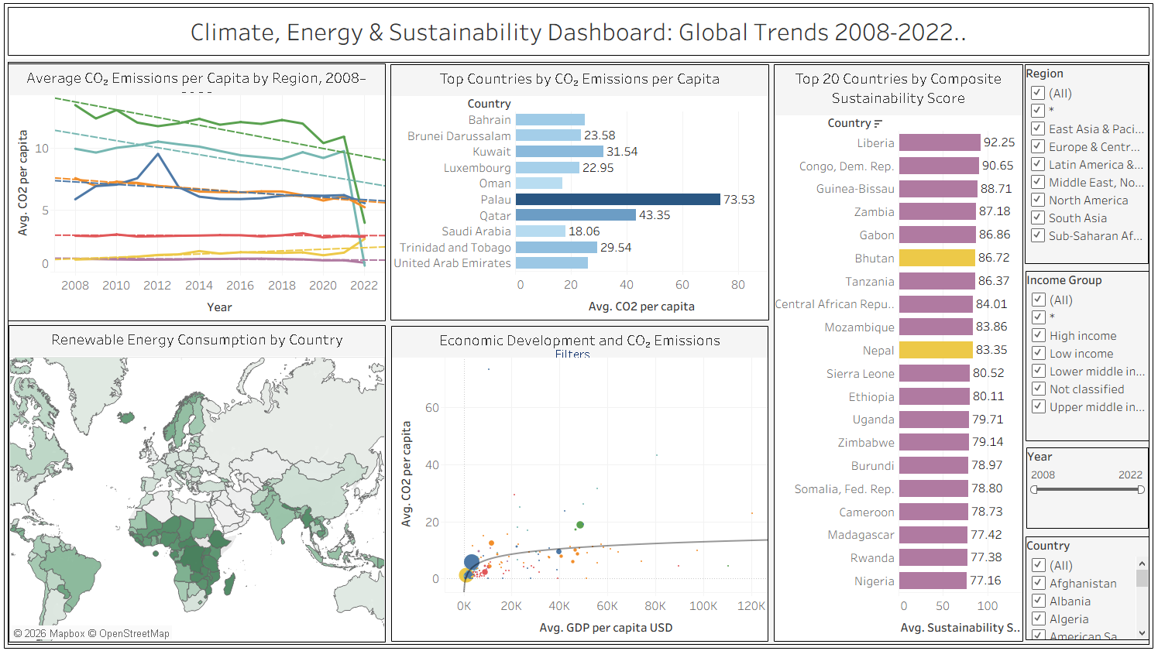
Figure 10. Integrated dashboard combining the regional CO2 trend, top emitters bar, renewables map, GDP-CO2 scatter, and sustainability ranking with interactive Region, Income Group, Year and Country filters.
Interactivity of three layers was constructed. Regions, Income Groups, Year and Country filters apply to all worksheets, so one filter can be applied to all charts at once. Parameters (Top N Countries, Select Year) alter what is shown, and leave the data alone. A filter action causes each nation on the map to become a cross filter, and a highlight action to become a highlight.

3.2 Excel Component
The brief demanded at least one high-level Excel visualisation, two were created because they answer different questions than Tableau.

3.2.1 Pivot Chart with Slicer
Figure 11 displays a PivotTable cross-tabulating Region by Year on average CO2 per capita, presented as a Pivot Chart with an Income Group slicer. The contribution to the analysis is the slicer: a single click filters the pivot to a preferred income level, revealing a pattern that the Tableau dashboard does not isolate as cleanly even where it is a numerical minority in the region.
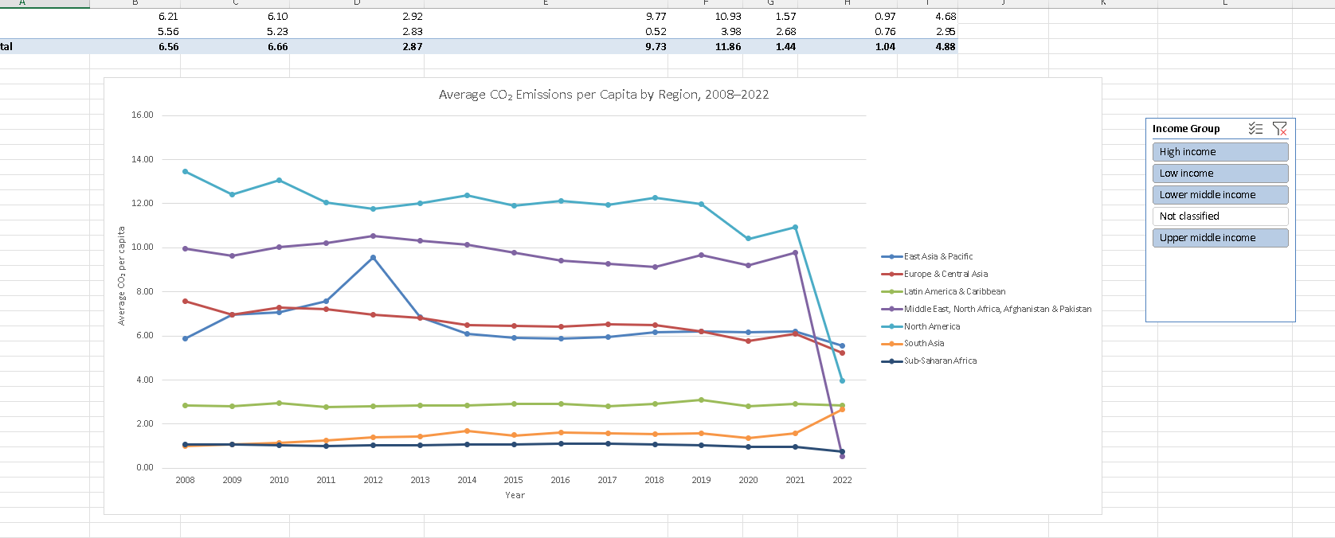
Figure 11. Excel Pivot Chart of average CO2 per capita by Region and Year, with an Income Group slicer for interactive filtering.

3.2.2 Combo Chart with Dual-Axis
Figure 12 uses the CO₂ per capita as columns on the primary y-axis and renewable share as a line on the secondary y-axis. Breaching down to a single image, the global narrative can be read: CO₂ traces a slow decline whereas the renewable line oscillates around 30% with a recent upsurge. The reason why the dual-axis is suitable is that the two series are conceptually related but measured on incompatible scales one of the few instances where Few (2012) supports the technique.
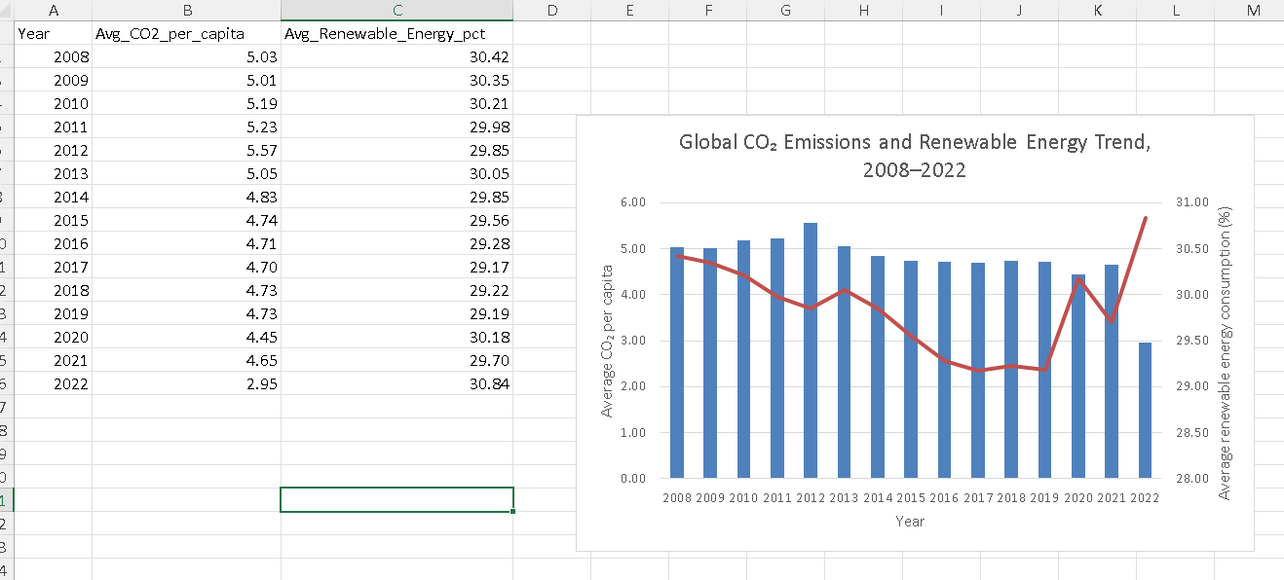
Figure 12. Combo chart showing global CO2 per capita (columns) and renewable share (line) on a dual-axis, 2008–2022.

CHAPTER FOUR: JUSTIFICATION OF TABLEAU FEATURES AND REFLECTION

4.1 Tableau Features Used
The dashboard utilizes the key features of Tableau, each of which has an analytical purpose. Calculated fields (Sustainability Score, CO2 Total megatons, Emission Category, Selected Metric) add derived measures to the dataset, which are referred to by name in downstream visualisations. Parameters (Select Year, Top N Countries, Metric Selector) are used in place of fixed views with parameters that are controllable what Few (2012) calls the boundary between reporting and exploration. The assignment of geographic roles to Country_Code will unlock the coordinates generated by Tableau to choropleth map. Trend lines visually surface statistical structure, with linear and logarithmic variants selected to appropriately surface the residual dispersion. The cross-chart interactivity that a dashboard provides as opposed to a set of thumbnails is generated by dashboard filter and highlight action. Colour was used sparingly: sequential green to represent renewables, divergent red-yellow to represent CO2, and the accessibility-tested categorical palette of Tableau to represent region was inspired by Kirk (2019) warning that decorative colour is distracting to interpretable signal.

4.2 Reflection on Trends
Finding 1: Real decoupling at the peak of the income distribution. The regional average CO2 of Europe & Central Asia dropped by 19.5 percent between 2008 and 2021 (reduced by 7.58 to 6.10 tonnes per capita) while the regional GDP increased, and the high-income share of renewable dropped to 16.0 percent. Luxembourg (–9.85 tonnes), Estonia (–5.90), Finland (–4.17) and Denmark (–4.16) had the largest individual decouplers. The correlation between log(GDP) and CO2 (r = 0.43) in 2021 confirms that the income-emissions relationship is becoming less strong and yet not entirely broken.
Finding 2: Pressure of industrialisation on South Asia. The growth in per-capita CO2 in South Asia was 55 percent relative (1.01-1.57 tonnes) growth between 2008 and 2021. The absolute levels are modest but the trend is similar to the historical curve that was followed by the high-income economies in the late twentieth century. As the population of the region is modest, small per-capita changes grow into large counterfactual emissions-avoidance values.
Finding 3: Biomass paradox in the Sustainability Score. Low-income Sub-Saharan economies whose share of renewable is based on traditional biomass, not modern infrastructure, dominate the composite leaderboard. It is internally consistent the formula does not lie but it demonstrates the general criticism of composite indicators of Greco et al. (2019): aggregation may conceal the structurally different underlying realities. Countries that burn firewood and countries that use wind farms can be rated on the renewable axis with similar results, but the policy implications cannot be more antithetical.

4.3 Limitations
There are three restrictions that any application of this dashboard is classified. On the one hand, 2022 reports only 65 out of 199 countries, and so trend statements are anchored on 2008-2021. Second, the per-capita emissions ignore the cumulative past responsibility the United States has emitted about a quarter of all historical CO2 even though it has 4% of the current population (Ritchie and Roser, 2024). Third, the inability of the renewable indicator to differentiate between modern renewables and traditional biomass biases the leaderboard towards lower-income countries and is the most consequential measurement weakness of the dataset.

CONCLUDING REMARKS

The dataset used in this assignment consisted of seven Tableau worksheets, an integrated dashboard, and two complementary Excel artefacts with 2,847 rows and 199 countries respectively. The work addresses the three learning outcomes of the module by a purposeful design choice instead of feature compliance: parameters, calculated fields and dashboard actions service LO1, the documented preparation pipeline and chart-type selection service LO2, the integrated dashboard and Excel component service LO3.
High-income regions are stabilising their emissions but industrialising South Asia is increasing. The rapidest growth in renewable adoption is in regions where the capacity to invest is the highest, whereas the high probability of renewable energy in the low-income economies is indicative of biomass dependency as opposed to the clean-energy transition.

BIBLIOGRAPHY
Esty, D.C., Levy, M.A., Kim, C.H., de Sherbinin, A., Srebotnjak, T. and Mara, V. (2008) 2008 Environmental Performance Index. New Haven: Yale Center for Environmental Law and Policy.
Few, S. (2012) Show Me the Numbers: Designing Tables and Graphs to Enlighten. 2nd edn. Burlingame: Analytics Press.
Greco, S., Ishizaka, A., Tasiou, M. and Torrisi, G. (2019) 'On the methodological framework of composite indices: a review of the issues of weighting, aggregation, and robustness', Social Indicators Research, 141(1), pp. 61–94.
International Energy Agency (2024) World Energy Outlook 2024. Paris: IEA. Available at: https://www.iea.org/reports/world-energy-outlook-2024 (Accessed: 04 May 2026).
IPCC (2023) AR6 Synthesis Report: Climate Change 2023. Geneva: Intergovernmental Panel on Climate Change. Available at: https://www.ipcc.ch/report/ar6/syr/ (Accessed: 04 May 2026).
Kirk, A. (2019) Data Visualisation: A Handbook for Data Driven Design. 2nd edn. London: SAGE Publications.
Ritchie, H. and Roser, M. (2024) 'CO2 and Greenhouse Gas Emissions', Our World in Data. Available at: https://ourworldindata.org/co2-and-greenhouse-gas-emissions (Accessed: 04 May 2026).
Stern, D.I. (2017) 'The environmental Kuznets curve after 25 years', Journal of Bioeconomics, 19(1), pp. 7–28.
Tableau Software (2024) Tableau Desktop User Guide. Seattle: Tableau Software. Available at: https://help.tableau.com (Accessed: 04 May 2026).
United Nations (2015) Transforming Our World: The 2030 Agenda for Sustainable Development. New York: United Nations. Available at: https://sdgs.un.org/2030agenda (Accessed: 04 May 2026).
World Bank (2026) World Development Indicators. Washington DC: World Bank. Available at: https://data.worldbank.org (Accessed: 04 May 2026).

APPENDIX

Appendix A - Final Dataset Schema
The cleaned master dataset (cleaned_climate_dashboard_data.csv) contains 2,847 rows and 21 columns covering 199 countries and 7 World Bank regions across the period 2008–2022.
Column | Type | Description
Country, Country_Code | Text | Country name and ISO-3 code.
Region, Income_Group | Text | World Bank classifications.
Year, Period | Number / Text | Year (2008–2022) and grouped period.
CO2_per_capita | Decimal | Tonnes CO2e per person.
Renewable_Energy_pct | Decimal | % of total final energy from renewables.
Energy_Use_per_capita | Decimal | kg oil equivalent per person.
GDP_per_capita_USD, GDP_Level | Decimal / Text | USD and quartile classification.
Population | Integer | Total population.
Electricity_Access_pct, Forest_Area_pct | Decimal | Coverage indicators.
CO2_Total_megatons | Decimal | Calculated: CO2_per_capita × Population / 1e6.
Emission_Category | Text | Low / Medium / High / Very High.
Sustainability_Score | Decimal | Composite (0–100).
Capital_City, Latitude, Longitude | Text / Decimal | Geographic enrichment.

Appendix B — Tableau Workbook Contents
- Worksheet 01 — CO2 Trend by Region
- Worksheet 02 — Top N CO2 Countries
- Worksheet 03 — Renewable Energy Map
- Worksheet 04 — GDP vs CO2 Scatter
- Worksheet 05 — Regional CO2 Heatmap
- Worksheet 06 — Sustainability Ranking
- Worksheet 07 — Renewables by Income Group
- Dashboard — Climate Sustainability Dashboard

Appendix C — Excel Workbook Contents
- Pivot_table_data — raw structure for the pivot
- Pivot_CO2_Region — pivot table, pivot chart, and Income Group slicer
- Combo_CO2_Renewables — dual-axis combo chart
- Cleaned_Data — full cleaned dataset
- All_Cleaned_Country_Years — pre-merge raw long-format file
- Missingness — diagnostic on missing values per indicator

